Inspection Date | 02-03-2023 | Report Ref. No. | MACINS065 -02/3/2023
Site Name | Main Campus | Location | A02006, A02007, A02008, A02012  Biomedical Engineering, A Building
Inspected By | Roberto Macahig | Witnessed by | Sarah Saeed Mohammed Bawazir

Inspection Type | ☑General ☑Housekeeping & Sanitation ☑Fire ☑Electrical ◻Ladders ☑Lab ◻Food ◻Structure ◻Motor Vehicles ◻Landscaping ◻PPE ◻Stores ☑Emergency Evacuation

Findings
 | ☑ Safety ◻ Environment ◻ Occupational health
S/N | Description | Significant Risk  Yes/No | Risk Evaluation
S/N | Description | Significant Risk  Yes/No | Low | Med | High
 | Fire System in all Labs (A02006, A02007, A02008, A02012) to be confirmed as Civil defense approval required before full operation. | Yes |  |  | √
 | Pre-operational inspection will be performed with Lab Engineer to confirm the lab requirements. | Yes |  |  | √

Attachment | ☑Photos ◻ Video Footage ◻Other

Corrective actions
S/N | Description
 | Short Term Action |  | Long Term Action |  |  |  | By Whom |  |  |  | By When
 | FM/contractor are coordinating with civil defense |  |  |  |  |  | Project Team/ FM Hard Service |  |  | 30 May 2023
 | Check to be performed with Lab Engineer. |  |  |  |  |  |  |  |  | 30 May 2023
Prepared by: ESH Section |  |  |  | Received by: Sarah Saeed Mohammed Bawazir |  |  |  |  | Followed up by:
 |  |  |  | Contractor: NA |  | Consultant: |  |  | ◻ Corrective Action is taken |  |  | ◻ Corrective action not taken
Name |  | Roberto Macahig |  | Name |  | Name |  |  | Name
Designation |  | Lab Safety Specialist |  | Designation |  | Designation |  |  | Designation
Signature |  |  |  | Signature |  | Signature |  |  | Signature
Date |  |  |  | Date |  | Date |  |  | Date

Attached Photos

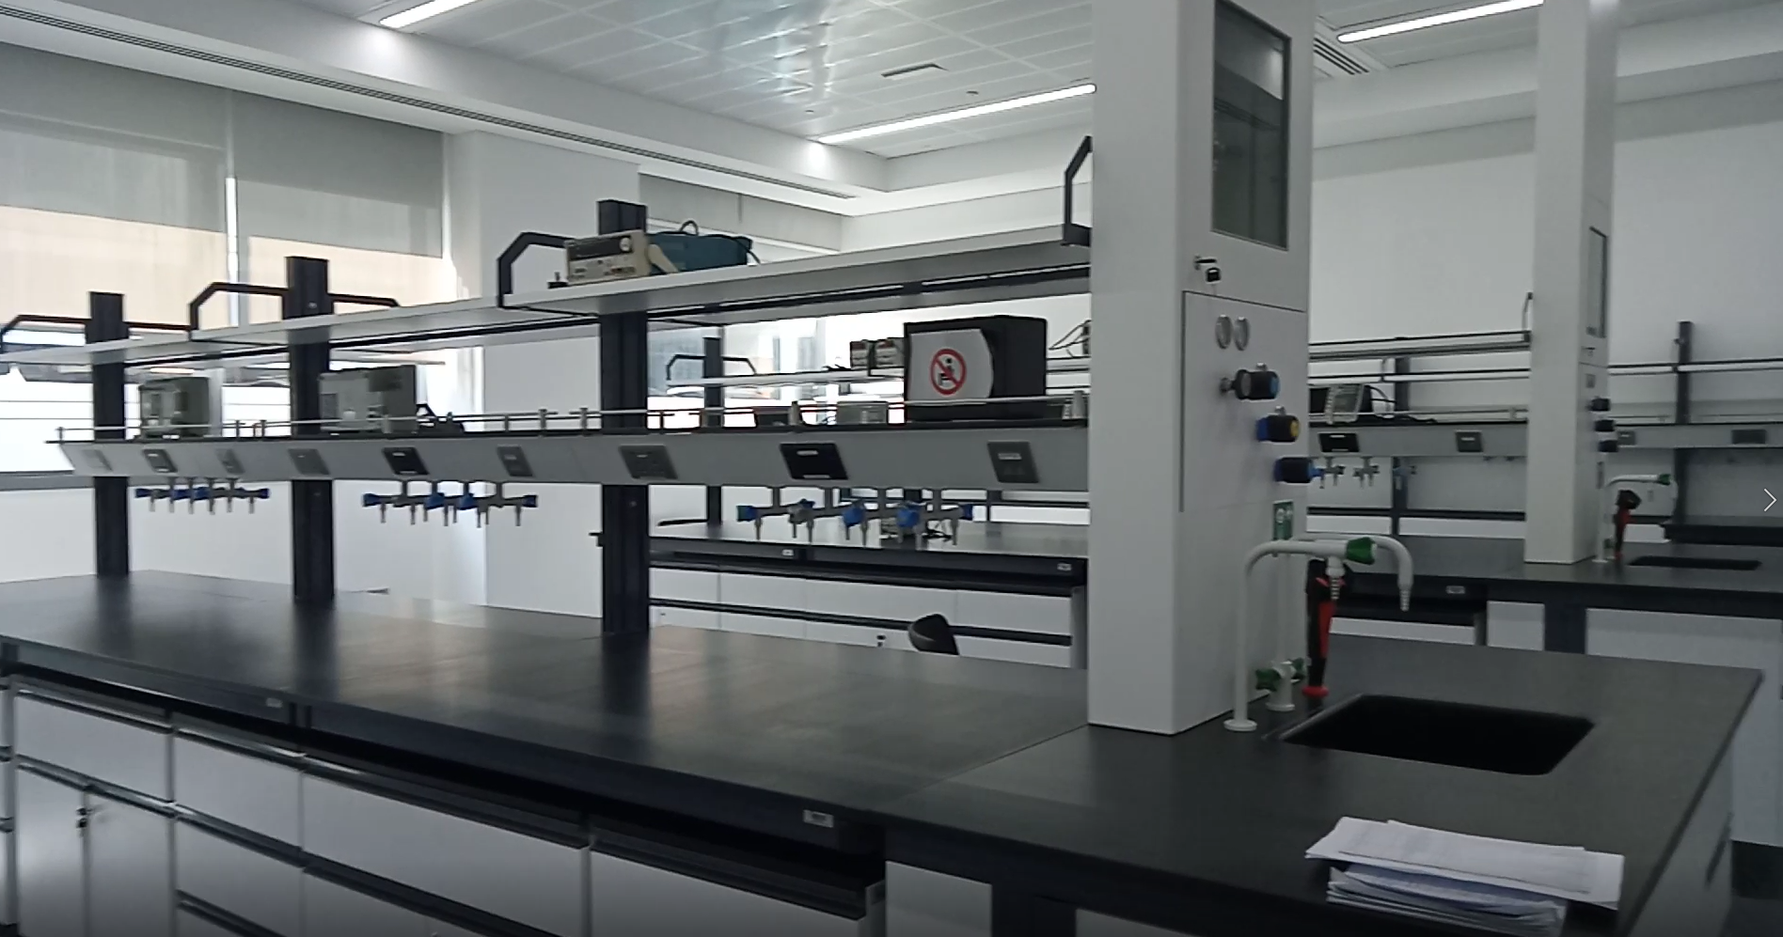 | 